1. ***Create a StudentRegistry app using HashSet to store student names. Ensure no duplicates.***

import java.util.*;

class StudentRegistry {

public static void main(String[] args) {

HashSet<String> students = new HashSet<>();

Scanner scanner = new Scanner(System.in);

System.out.println("Enter student names (type 'exit' to stop):");

while (true) {

System.out.print("Student name: ");

String name = scanner.nextLine();

if (name.equalsIgnoreCase("exit")) break;

if (students.add(name)) {

System.out.println("Added: " + name);

} else {

System.out.println("Duplicate entry. Not added.");

}

}

System.out.println("\nRegistered Students:");

for (String student : students) {

System.out.println("- " + student);

}

scanner.close();

}

}

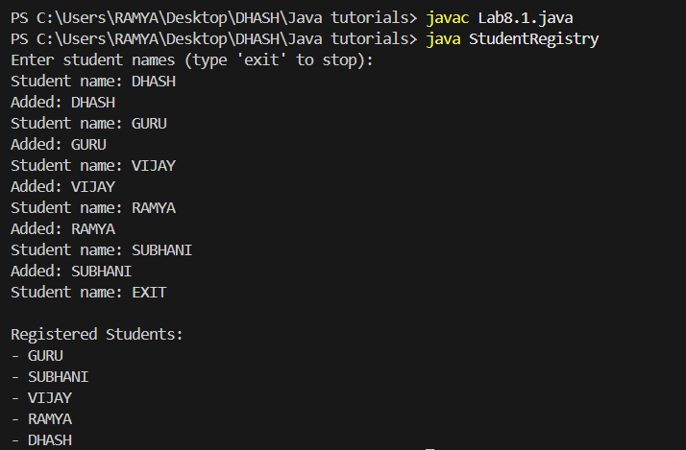

1. ***Create a ProductCatalog using TreeSet that auto-sorts product prices.***

import java.util.*;

class ProductCatalog {

public static void main(String[] args) {

TreeSet<Double> productPrices = new TreeSet<>();

Scanner scanner = new Scanner(System.in);

System.out.println("Enter product prices (type -1 to stop):");

while (true) {

System.out.print("Price: ");

double price = scanner.nextDouble();

if (price == -1) break;

if (productPrices.add(price)) {

System.out.println("Added: $" + price);

} else {

System.out.println("Duplicate price. Not added.");

}

}

System.out.println("\nProduct Prices (Sorted):");

for (Double price : productPrices) {

System.out.println("$" + price);

}

scanner.close();

}

}

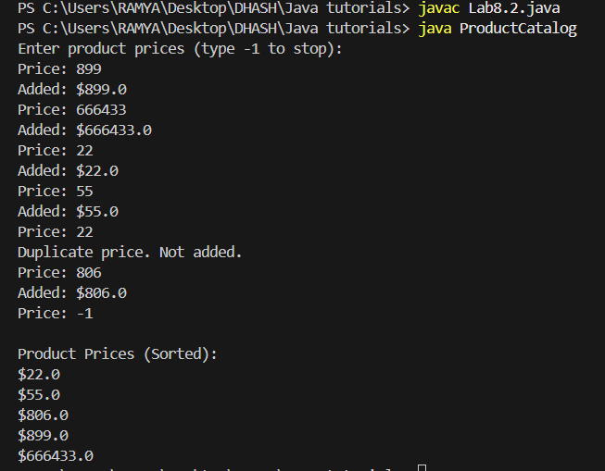

***3. Take a list of 10 cities (with duplicates) and use LinkedHashSet to remove duplicates and preserve the order.***

import java.util.*;

class CityListCleaner {

public static void main(String[] args) {

List<String> cities = Arrays.asList(

"Chennai", "Mumbai", "Delhi", "Chennai", "Bangalore",

"Hyderabad", "Kolkata", "Mumbai", "Pune", "Delhi","Thirchy"

);

System.out.println("Original List with Duplicates:");

System.out.println(cities);

LinkedHashSet<String> uniqueCities = new LinkedHashSet<>(cities);

System.out.println("\nCities after removing duplicates (Order Preserved):");

for (String city : uniqueCities) {

System.out.println(city);

}

}

}

